A

PROJECT REPORT ON

**Data Visualization Using Tableau of**

**Horticultural dataset**

Submitted By

**AKSHAY PATIL (BE19S03F008)**

From

**GOVERNMENT COLLEGE OF ENGINEERING**

 **AURANGABAD**

Under The Guidance Of



**1 INTRODUCTION**

**1.1 Overview**

India is an agricultural nation. Around 70 % of its population is engaged in agricultural activities. **Horticulture** is subdivision of **agriculture** which deals with gardening of plants.The gardening can be in an enclosed environment ,although it is not essential. In this project we are trying to visualize the dataset made available by the government of India on Horticulturural crop production over years. the dataset is from 2009 to 2015, and has production, area and productivity information of various horticultural crops such as vegetables,fruits,flowers,spices,aroma,medicinal,and plantational crops.

Now as this dataset contains large number of values of different states in India over the course of six years, we are trying to visualize this dataset using the powerfull Tableau data visualization software. we will represent the information on business intellegent interactive dashbords and also highlight some key insights from the dataset in the storypoints.

**1.2 Purpose**

The purpose of this project is to solve the ambiguities and confusions regarding the multiple values present in the dataset. Also this project focuses on presenting all the information available in the most presentable and organised manner so that the user can get meaningfull insights required for taking appropriate steps in the future.

**2 LITERATURE SURVEY**

**2.1 Existing problem**

Currently we only have the horticultural dataset in exel sheet format. Even though we have all the data it takes a lot of time to find which state have highest production, because understanding that amount of text is a tedious task. And if we want the total sum of all production values then we need to add the values individually on our own. This process is very time consuming and confusing as well. It will take a lot of time to get meaningfull insights from the dataset.

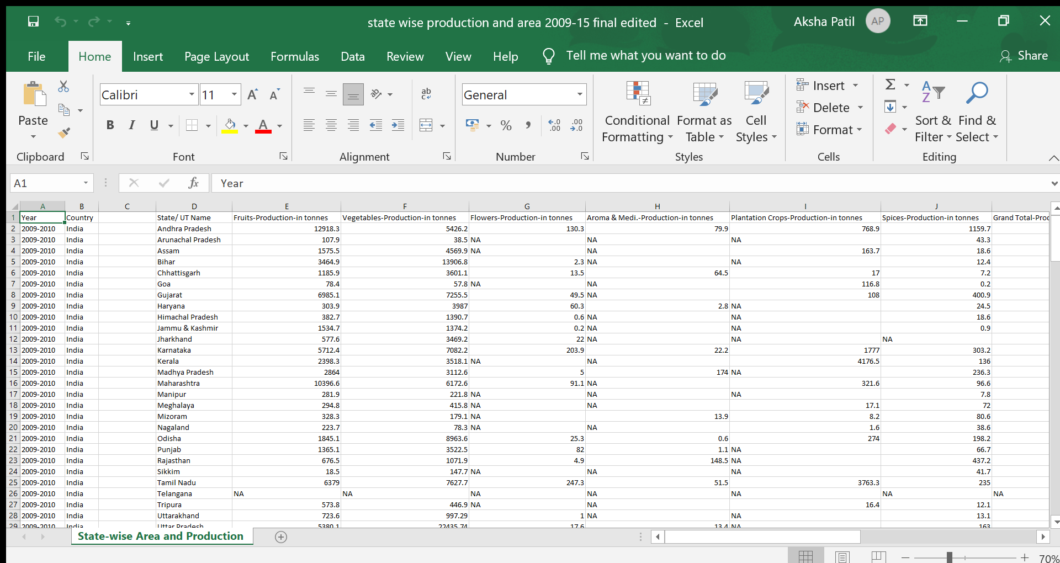

**2.2 Proposed solution**

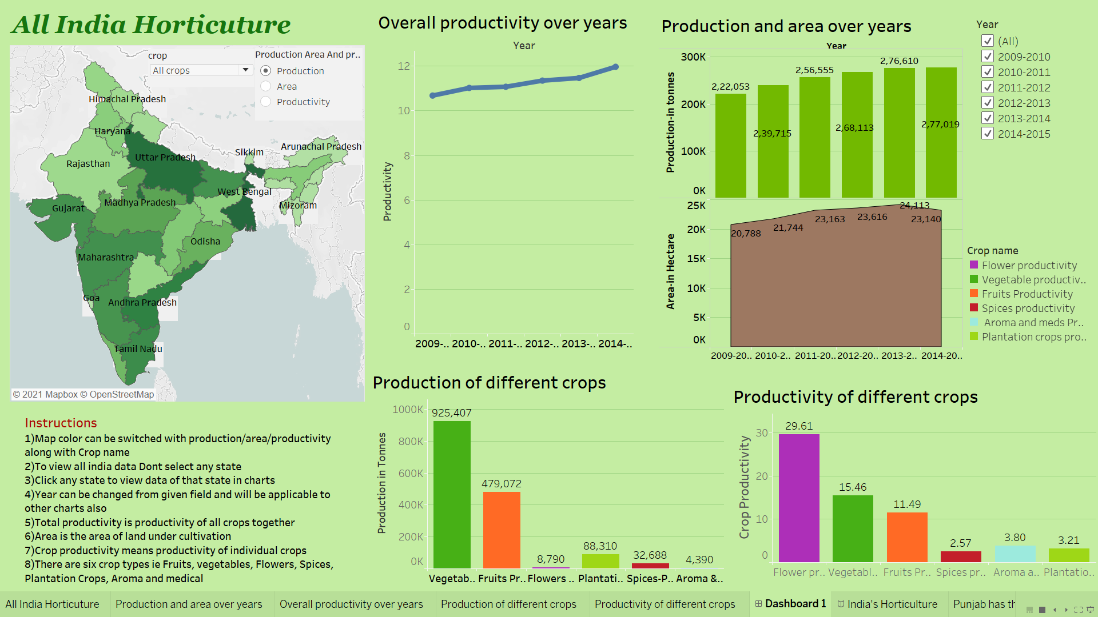The proposed solution is to analyze this data using the powerfull tableau software so that the calculations part will be accurately and rapidly handlled by the software itself. morever insted of having just the textual data we will be ploting various kinds of graphs and this way we will have a pictorial representation of our dataset and it would be very easy to compare various quantities over years ans states.

**3 THEORITICAL ANALYSIS**

The dataset is availbale on the data.gov website but is in the raw exel sheet format. So we need to import it in the tableau software and clean the unnessesory data.

**Connect To Data:-**

In the connect to data section choose the file type and open the location where the file is saved and choose the dataset file. The file will open in tableau and then drag the dataset on to the blank area so that youu will see the dataset.Hide the unnesessory data, rename the required firld and once the dataset is cleaned save it as a tableau data sourse.

**Designing the sheets:-**

Then we addes new sheets to the workbook and tried to plot vizualisations which were possible form the available fields and which would solve the questions of the vizualizer such as "what is the all india all time production?", Which state has the highest productivity?"

Focusing on these questions we plotted various graphs such as all india map showing production ,area and productivity of all states in a shade of colour. Productivity over the years showing variations in the overall productivity. Also we plotted production and productivity of various crops so that which crop is highly produced over years can be identified.

**Designing the dashboard:-**

After plotting all the required graphs we need to acomodate them in one dashboard where we could see all the plots simultaneously. for that we added all the plots on the dashboard and added required actions so that selecting a state in the map will filter all other polts as per the state selected. This way we can easily analize staewise and yearwise data for any quantity.

**Developing the Story:-**

Once you are done with analysing the dashboard and have the meaningfull insights is time for storytelling ie putting forward the insights in the form of stories.

for this we added new story page to the workbook and created the required stories saying " india productivity on the rise" , "punjb is the highly productive state" . So these are the key insights available and are shown on the story page as a focus.

**4 EXPERIMENTAL INVESTIGATIONS**

While working on the solution it was observed that not all datasets are properly organised so in order to have insights properly we manually need to do some changes in the arrangement of the dataset so that the task becomes very easy for the analyser. example this dataset was not organised yearwise so we had to manuallya dd the year field. Also it was observed that aggregate quantities such as productivity calculated field cannot be added to case function in the calculated field.. Also we leant that if you save datasourse as a tds then the workbook asociated will be deleted and will be available on opening the tds.

**6 RESULT**

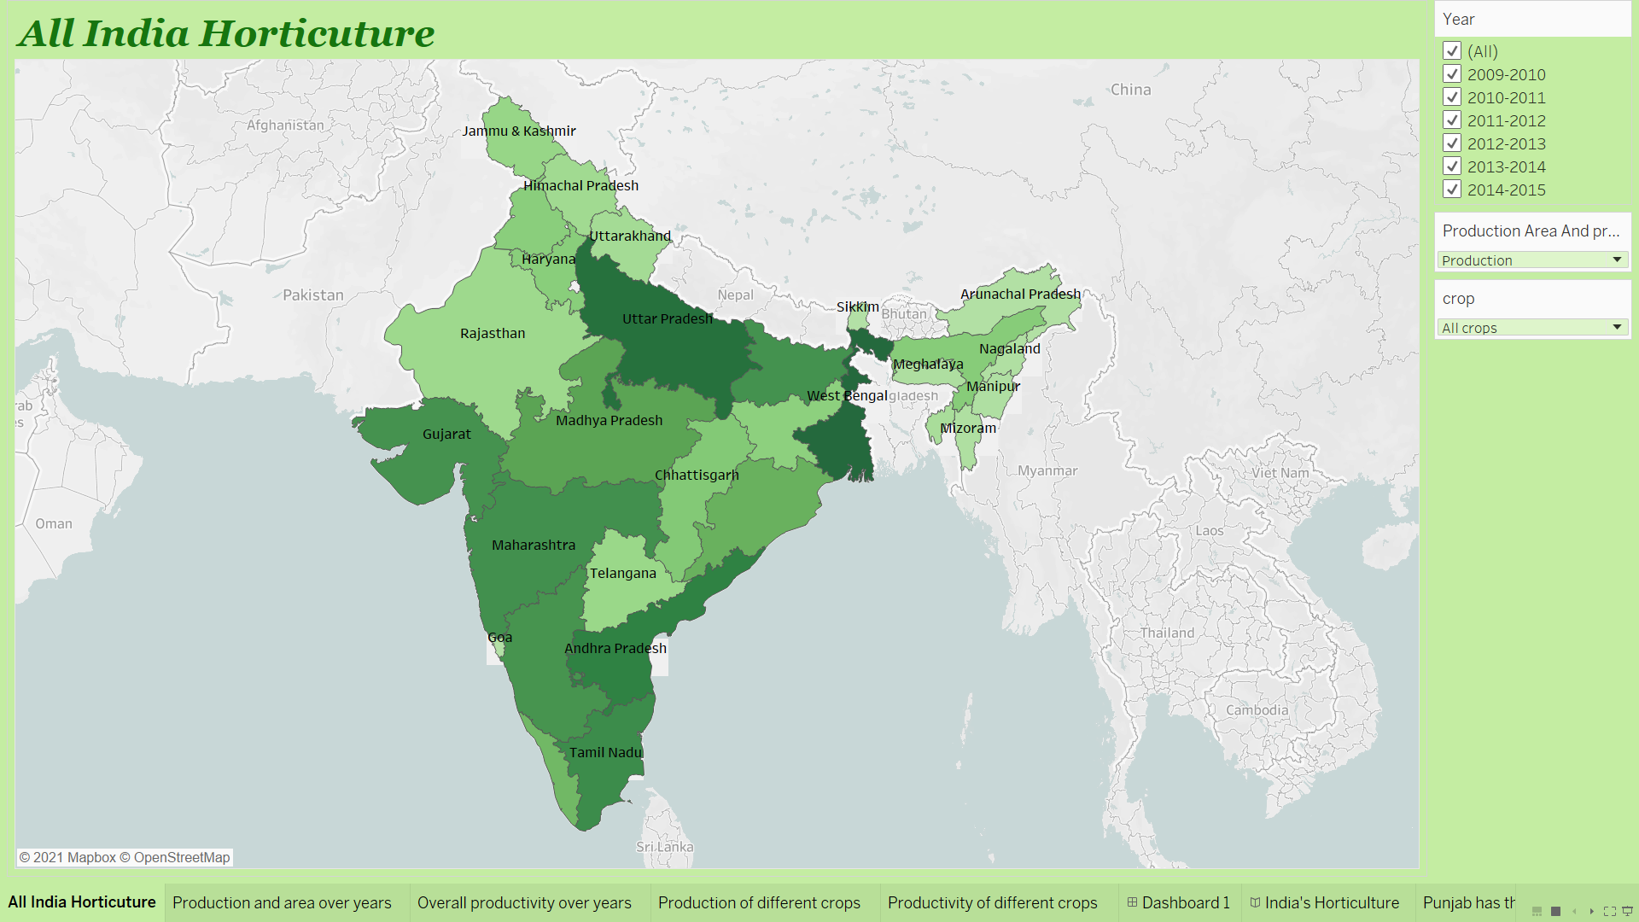 The project works as desired. It answers all the meaningfull questions of the user and shows the meaningfull insights appropriately. All the plot can be seen in the dashboard and change simultaneously if filtered through year or if a state is choosen on the map. This way it is easier to see the data and all questions can be answered on one page.

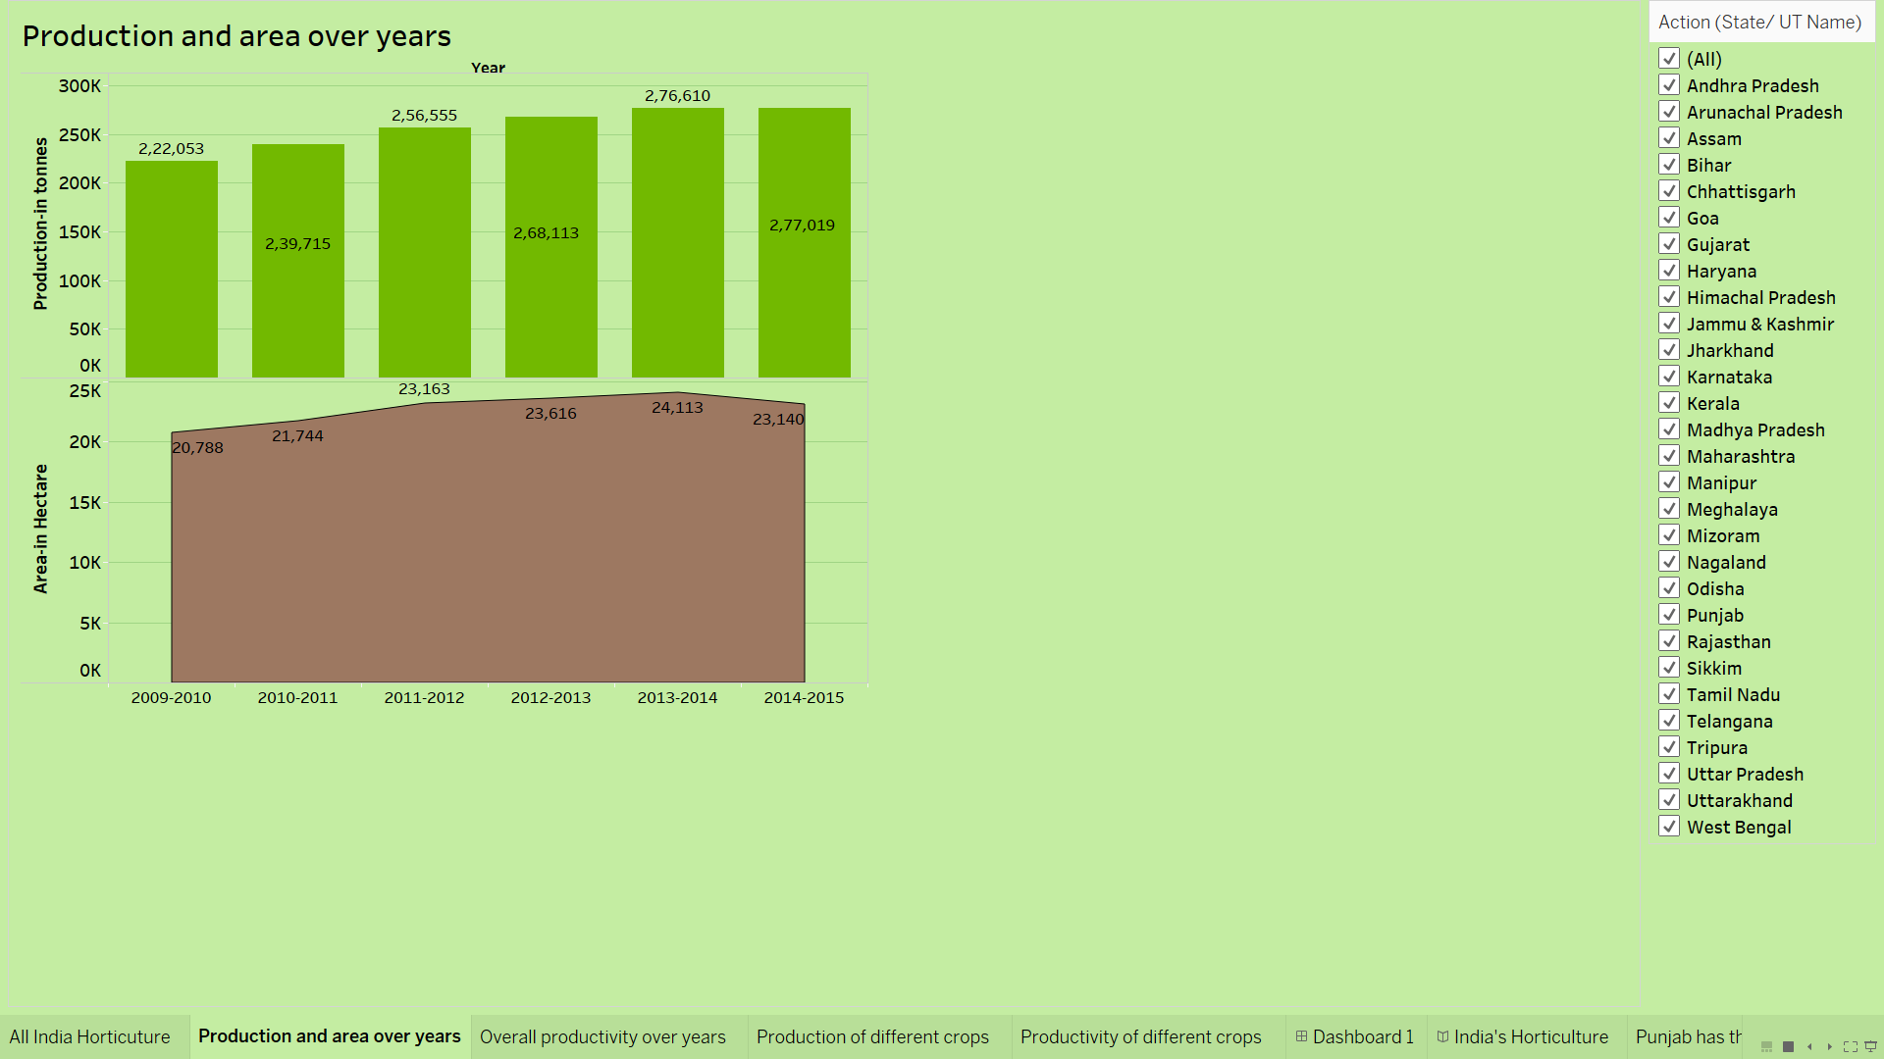

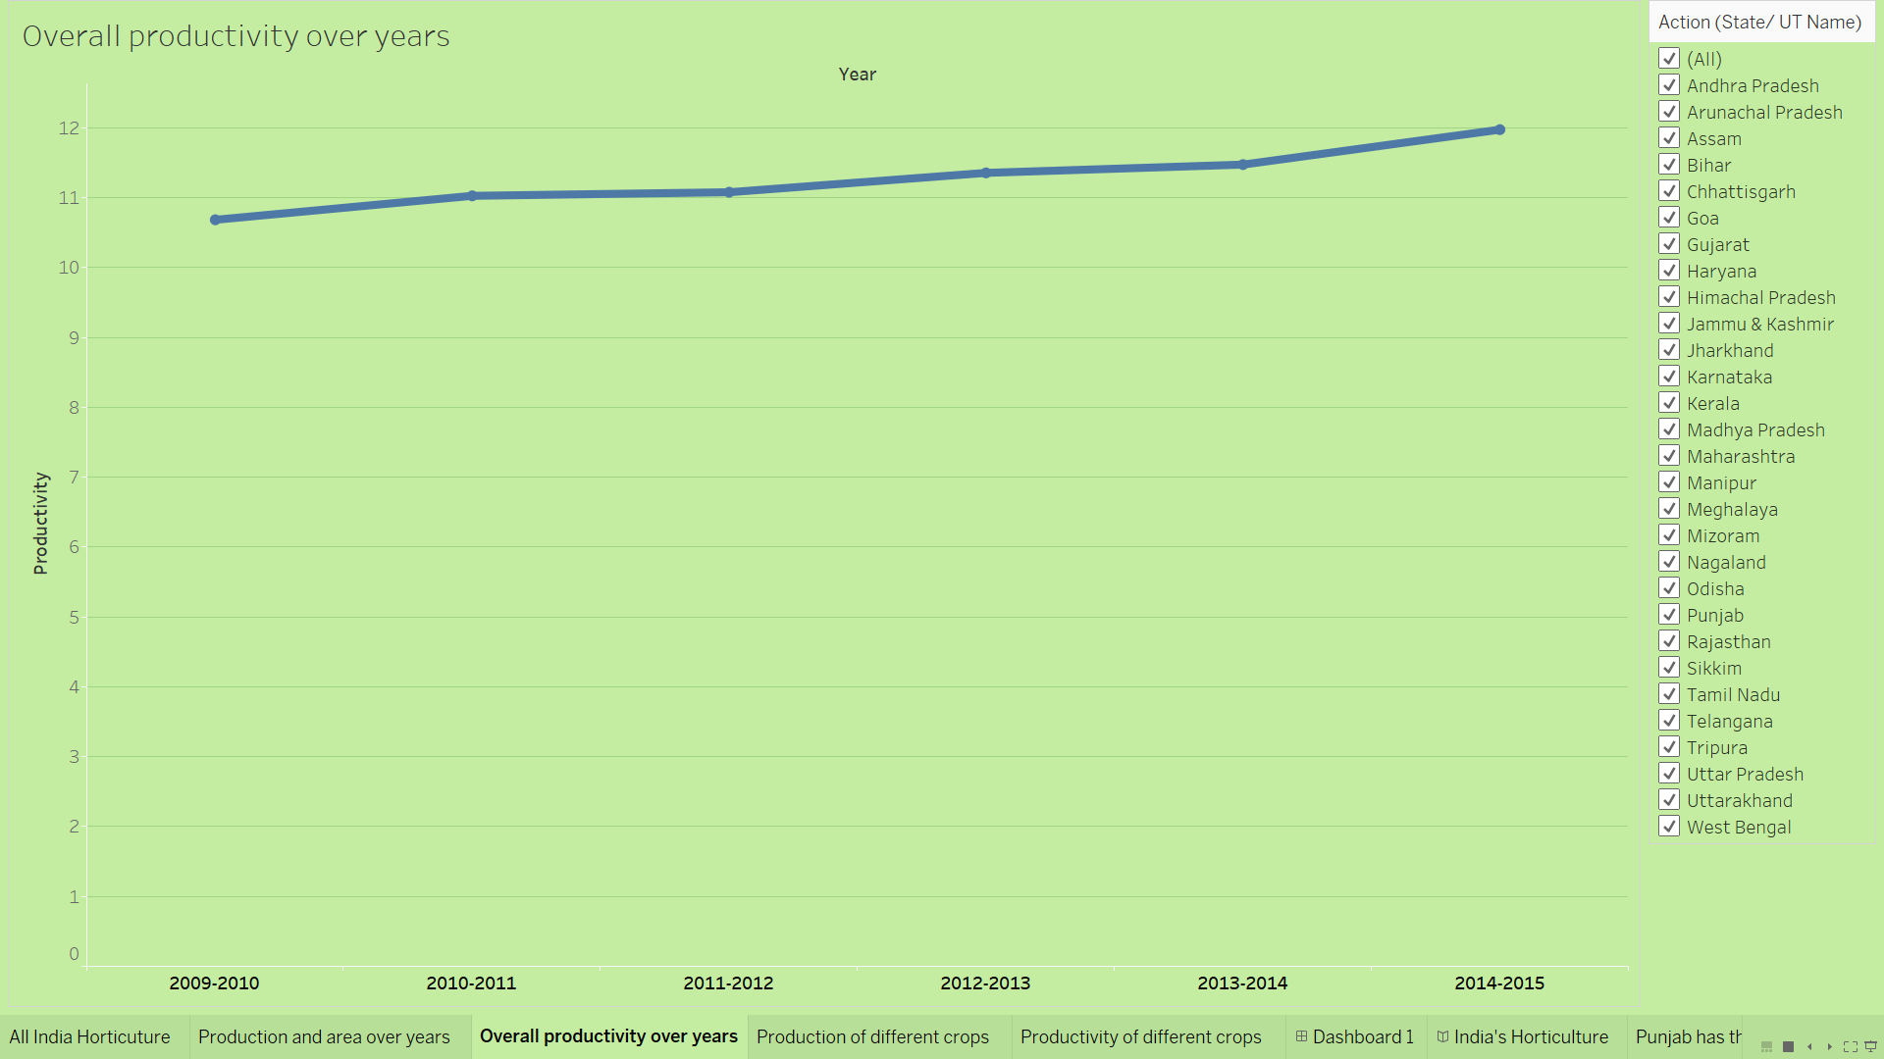

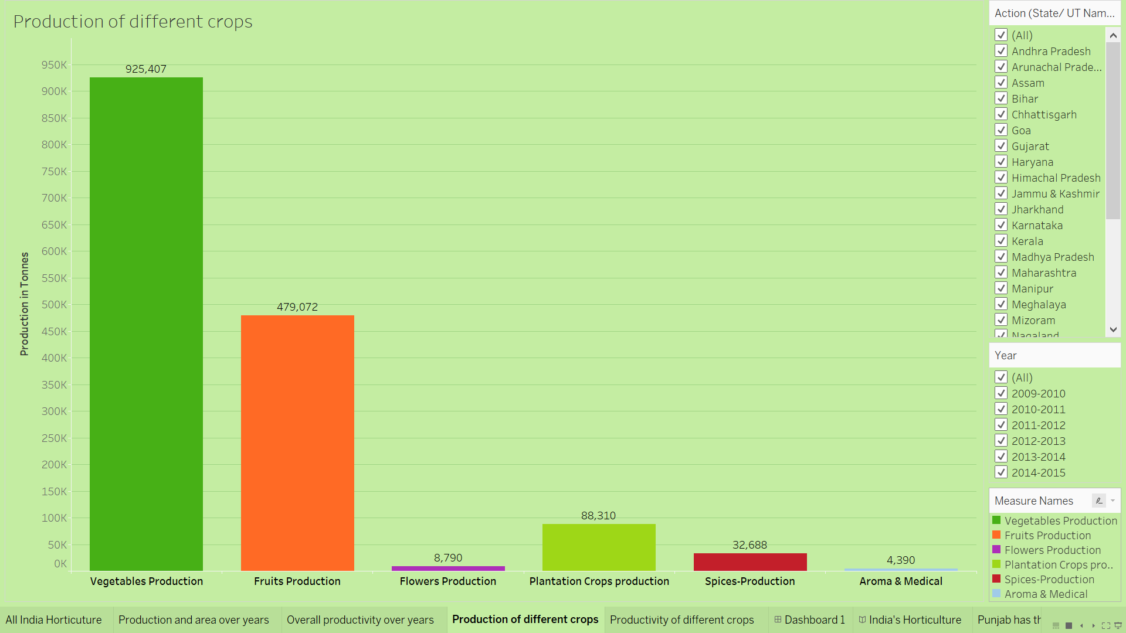

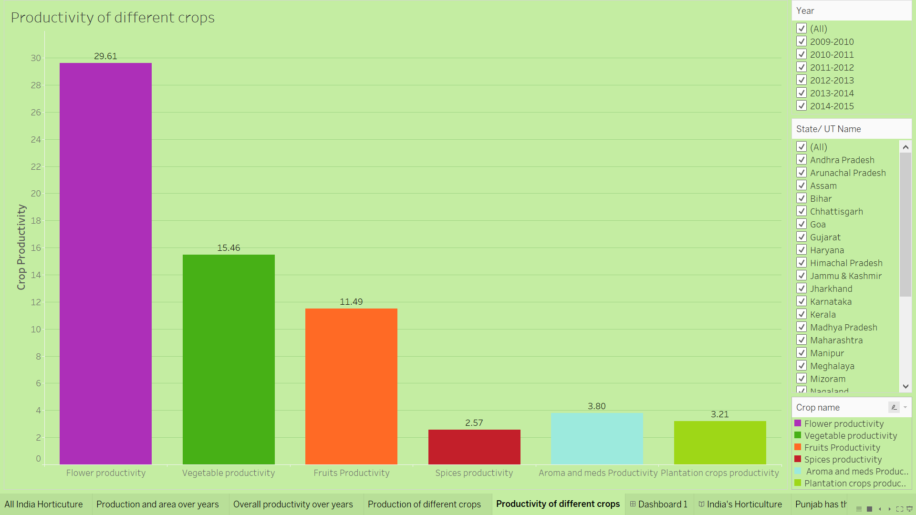



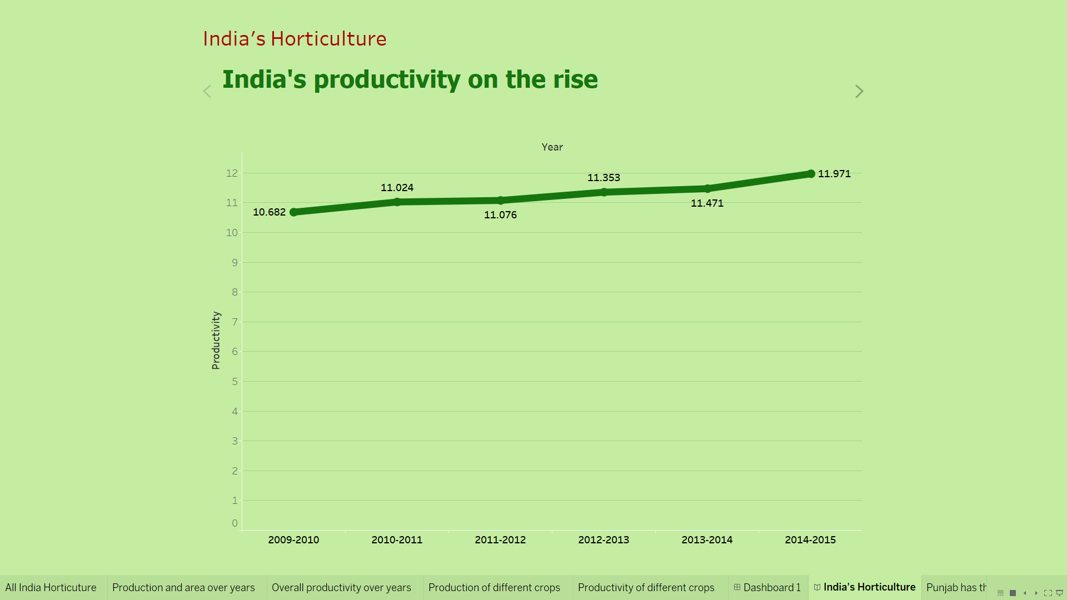

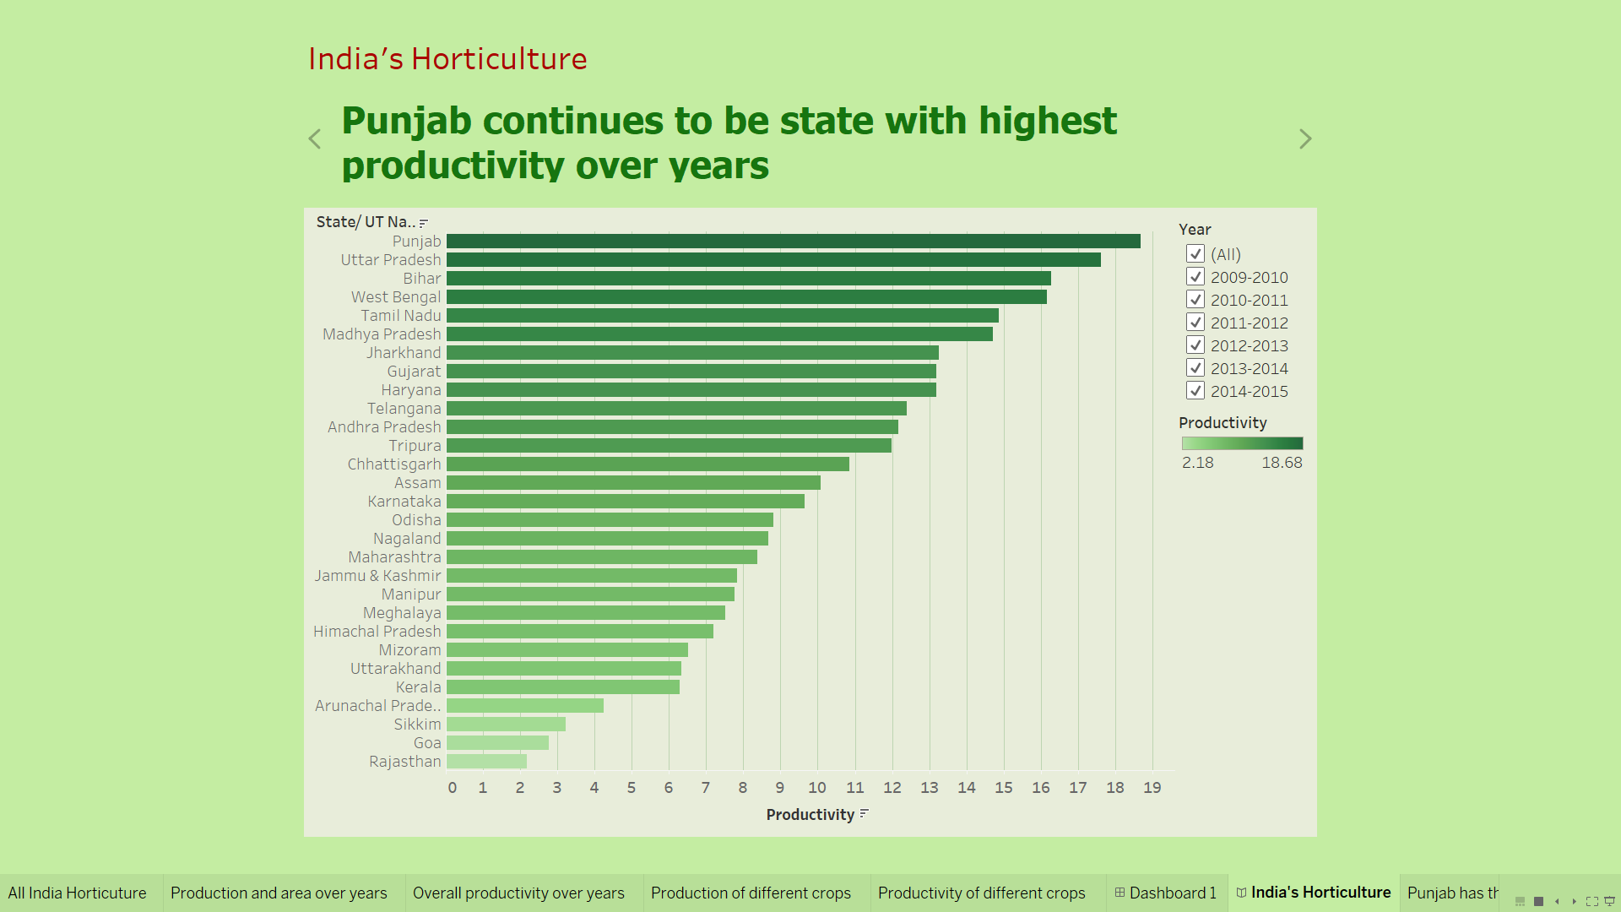

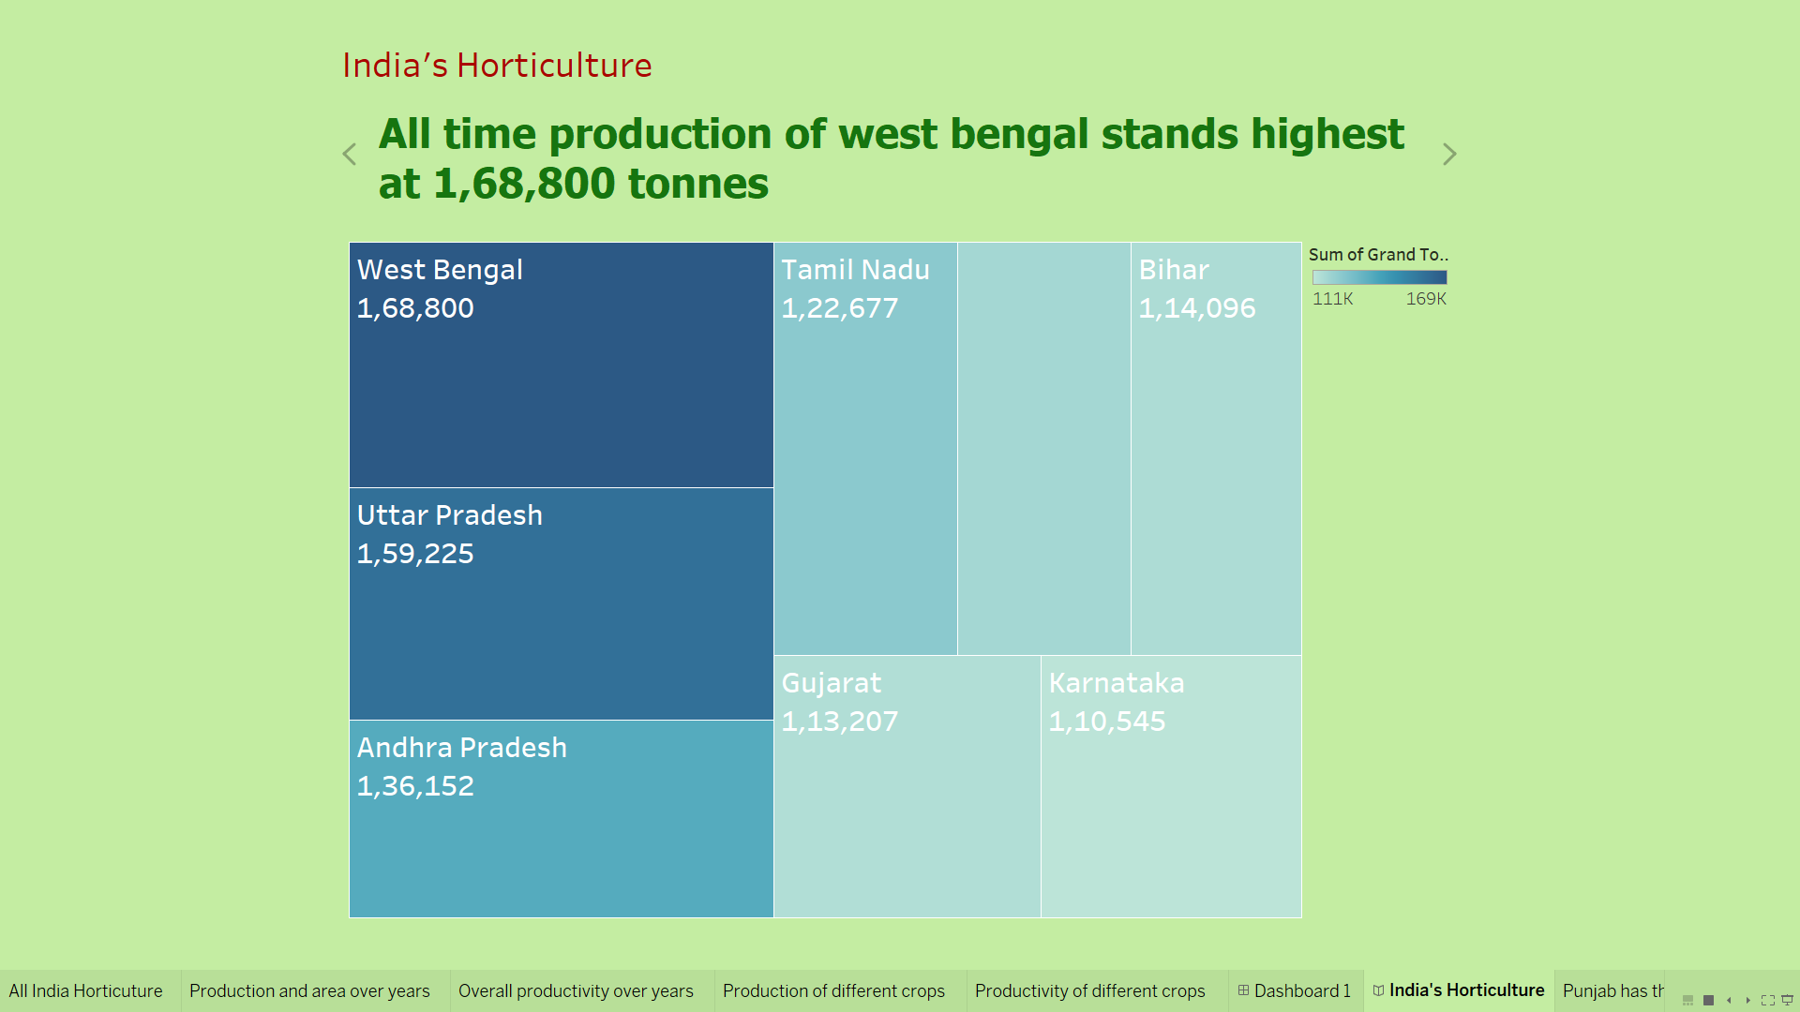

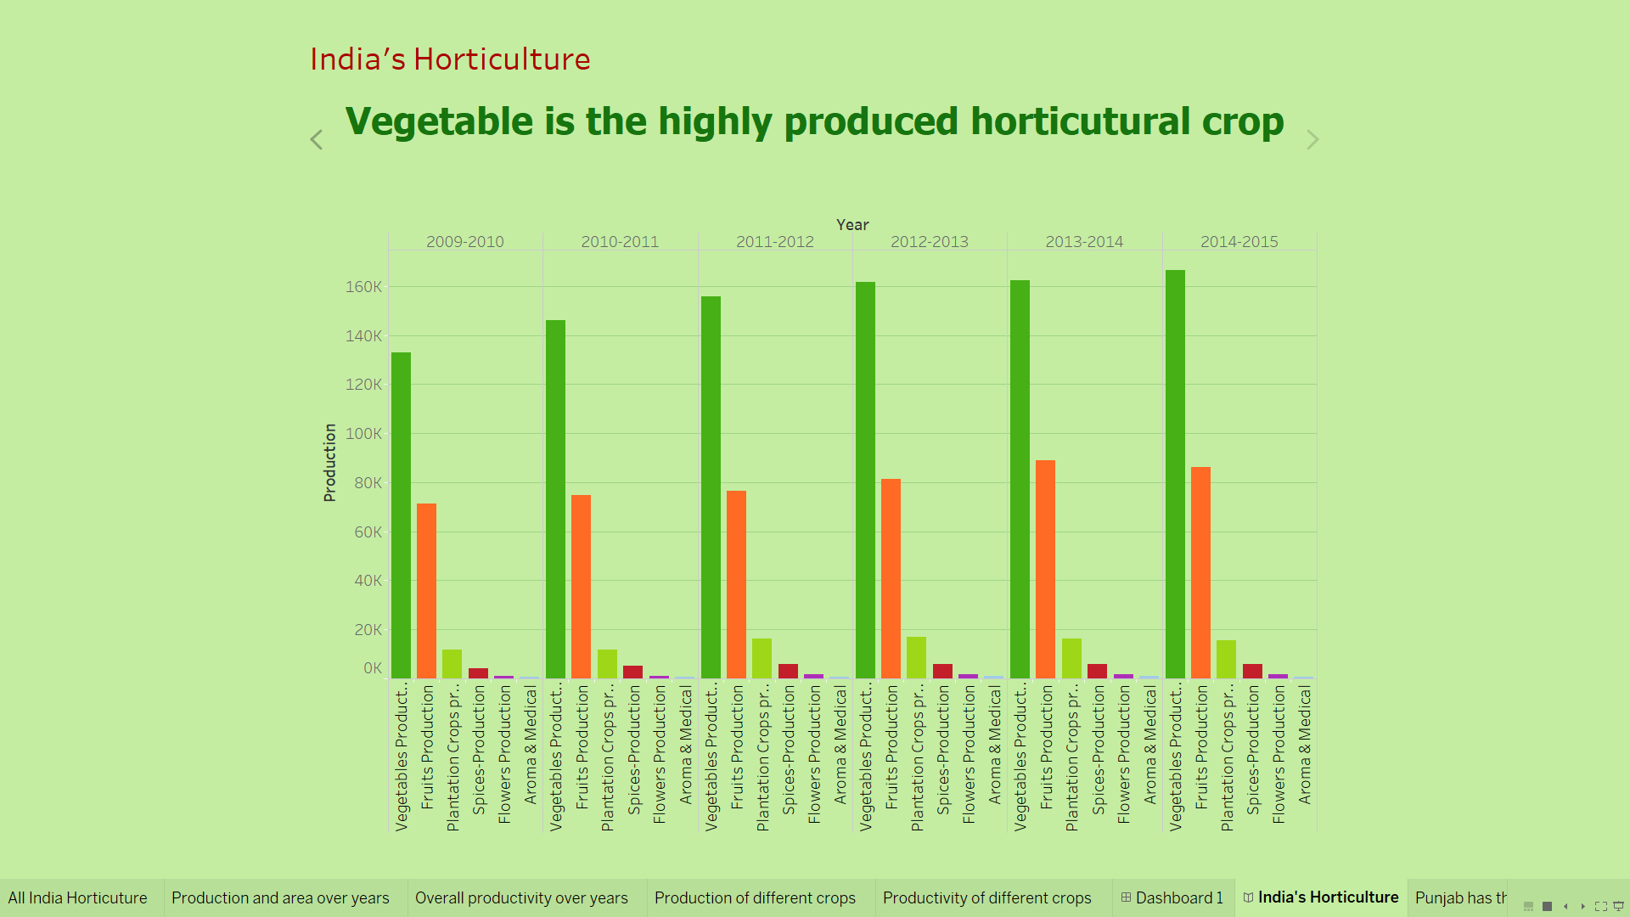

**7 ADVANTAGES & DISADVANTAGES**

**7.1 Advantages**

* However large the dataset, once the dashbord is designed insights are availbale within few clicks.
* All types of plots can be poltted using the software.
* data is processed within seconds
* most appropriate charts are autometically suggested.
* Horticulture data can now be visualized and future production can be planned.

**7.2 Disadvantages**

* takes time to plot the vizualizations if dataset is not organised.

**8 APPLICATIONS**

Typical applications include any kind of sector where data is generated and where insights matter and can be user for making a change. example digital p;ower plants consumption visualization, agricultural production, industries, small business. data analytics can now be applied to any sector, any industries, where growth and change towards improvement matters.

**9 CONCLUSION**

The tableau business intelleggence dashboard provides the required insights and works as desired and can now be used to solve questions thrown by the user.

**10 FUTURE SCOPE**

Furthur this project can be modified to work with analytics using modeling and to give predictions based on the data given. this can also be done using tableau.

**11 BIBILOGRAPHY**

1. https://public.tableau.com/en-us/s/
2. https://www.tableau.com/learn/training/elearning
3. https://www.data.gov/

.